Subject : (SUPPLIER NAME) has invited you to join Choco

Hello,

Good news! We have partnered with Choco, the #1 ordering platform for suppliers and restaurants. With Choco, ordering is easier and faster, saving you up to 2 hours per day. You can now use Choco for all your ordering with us. And it's completely free.

With Choco you can :
- Access your product list in 2 clicks
- Browse our catalog and discover our full assortment
- Get alerts with new products and discounts
- Chat with our team directly in the app

More on this video : https://youtu.be/eXD5cUDtuWQ

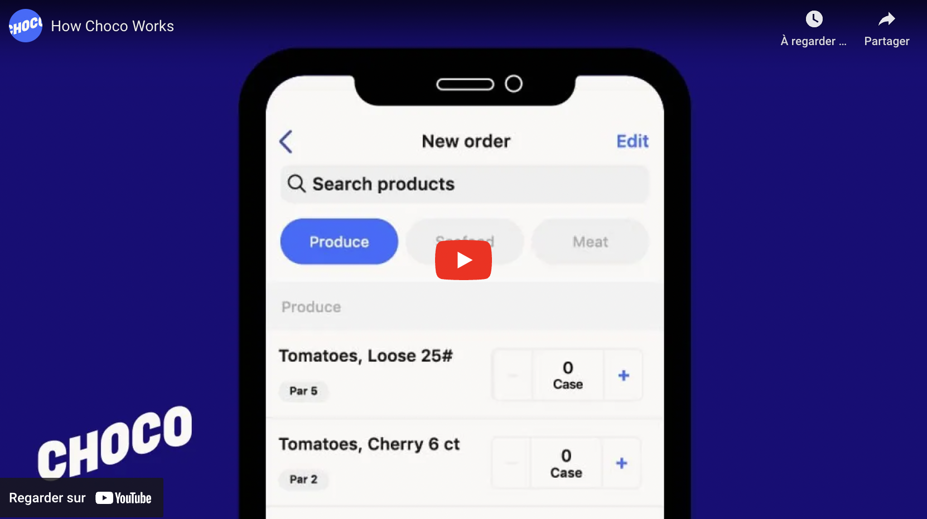

To start ordering, download the app here: www.getchoco.com.
Have a nice day !

